COSC 4324/5324

Fall 2018

Homework #3

Due: Sunday, September 16

**Submission Instructions**

Submit by midnight on the due date.

If you have other questions you need to ask, then feel free to use the instructor’s regular email account ([troden@lamar.edu](mailto:troden@lamar.edu)).

If you need to attach multiple files then compress all files into a single zip file. Use zip format (not 7zip, rar or any other compressed format). Microsoft Windows has zip functionality built in. Put all your files into a single directory and right click on the directory name and select “Send To Compressed (zipped) Folder.”

**General**

Using Visual Studio, write a C++ program that does the following:

1. Contains 2 functions – *main()* and *reorder().*
2. The *main()* function should:

- Print your name

- Dynamically allocate memory for 3 integer variables named x, y and z (this should be 3 separate allocations, don’t allocate an array)

- Generate 3 random numbers from 1-100 and store in the 3 integers. Use the system *rand()* function.

- Print the values of the 3 integers in order (x, y, z)

- Call function *reorder(),* passing pointers to the 3 integers

- After return from *reorder(),* print the values of the 3 integers in order (x, y, z)

3) The prototype for *reorder()* will be:

void reorder (int *n1, int *n2, int *n3);

4) Include the prototype for *reorder()* in your program.

5) The *reorder()* function should:

- sort the integers from lowest to highest, putting the smallest value in a, next to smallest in b and largest in c. This may involve swapping the values around.

*Note, this is all the *reorder()* function should do. Printing the values, etc. should be done in *main().*

**Items to Submit**

Submit the following files compressed into a single .zip file attachment:

1. Your source code (*.cpp) file.
2. A screenshot of Visual Studio with your program source code shown and the results of your program in a console window. Make sure your screenshot displays the 4 elements shown:

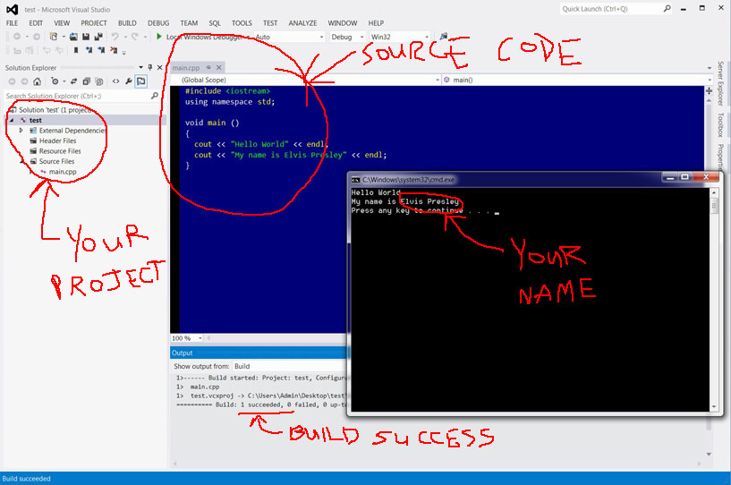

Note: You can capture a screenshot in Windows by pressing the PrintScreen button, opening Microsoft Paint and pressing Ctrl-V (to paste), then saving the picture as a .jpg file.